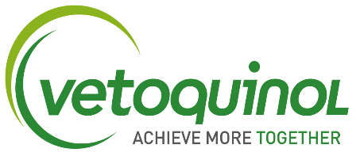

Regional Sales Manager – North

Full time
Permanent

Vetoquinol UK have an exciting opportunity for a Regional Sales Manager to join our team.

The Regional Sales Manager (covering the northern region) will help develop and deliver the strategy for Vetoquinol UK’s sales activities through the effective management of a team of Territory Managers and Business Development Managers. They will drive the sales management processes in accordance with the Company’s sales objectives and overall commercial strategy.

Main responsibilities of the role:
- Maximise market share, sales performance and Company profitability in line with annual budget process.
- Manage and develop field team effectively to ensure goals are achieved, continuing to build employee engagement whilst maintaining adequate resource levels and respecting budgets.
- Ensure the sales team resource allocation is optimised and in-line with Company’s segmentation and targeting strategy.
- Monitor account targeting and segmentation in CRM, collaborating with marketing for dynamic targeting.
- Foster a solution selling culture, leading through strategic account discussions, providing clear actions and results in line with the business strategy.
- Champion the Sales Excellence training programme within all aspects of the role, coaching the team during field visits.
- Deliver high quality workshops and training sessions on an internal and external basis as part of sales meetings, team training or customer CPD and events.
- Enforce adherence to the Company's commercial policy and provide required input and adjustments.
- Manage and build regional relationships to maximise the business opportunities in strategic accounts and the national Key Account Managers.
- Manage the commercial terms process for region, building on opportunities to gain and maintain business levels in targeted accounts.
- Excellent attention to detail and quality administration of role tasks ensuring timely completion and regular feedback, reporting and analysis.
- Gather and feedback competitive intelligence and market information analysis to relevant personnel and/ or departments in a timely manner, ensuring maximum advantage is gained for commercial actions and opportunities.

The successful candidate will be an established sales professional within the veterinary pharmaceutical industry and have experience of managing, coaching and developing high performing teams. They will have excellent commercial awareness and analytical skills and will be highly results focussed and target driven.

We offer a competitive salary + performance bonus, with a wide range of benefits including a company car/allowance, 25 days holiday, Private Medical Insurance and cashback, product allowance, profit related bonus, enhanced paid leave, enhanced private pension.

To apply for this role please submit your CV & covering letter specifying your salary expectation and notice period to uk_humanresources@vetoquinol.com

STRICTLY NO AGENCIES

