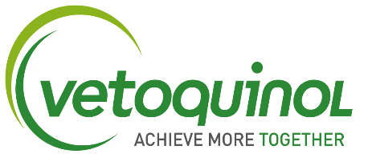
Territory Manager
Full-time, permanent role
Location – Central & South London (including Croydon, Crawley, Worthing)

This is an opportunity to join an established animal healthcare company in a permanent role as a Territory Manager. Vetoquinol is the 7th largest animal pharmaceutical company in the world and has a wide product portfolio with many well-known brands. Vetoquinol is also a company that is hugely invested in research and development, to find new and innovative products to bring to market, putting animal well being at the centre of our work. We also heavily invest in our people, to support, encourage and develop our team members throughout their career with us which is just one of the many reasons we achieved a Great Place to Work award!

What’s the role?
The role of Territory Manager is to achieve sales objectives with our veterinary partners by building fantastic relationships, delivering exceptional customer care, and maximising on opportunities for growth. These relationships will be with the Veterinary Surgeons and their teams, Regional Contacts for Buying Groups/Corporate Groups, relevant Decision Makers and Key Opinion Leaders.
The main responsibilities:
- Achieve yearly territory sales objectives and targets
- Sales of a range of products and services to new and existing customers
- Identify and present new and exciting opportunities within your territory in-line with strategic product objectives
- Complete administration tasks e.g. CRM in a timely and efficient manner as set by the Regional Sales Manager
- Build and maintain a call plan focusing on product campaigns, KPI objectives, customer prioritisation and your individual territory targets
- Establish internal relationships and lines of communication with supporting depts e.g. Marketing, Telesales, Key Accounts, Technical
- Attain and maintain an excellent working knowledge of the product portfolio, features and benefits and the competitors in the market
- Presenting to groups of veterinary professionals and providing training on products and therapy areas
- Attendance at quarterly sales meetings and exhibitions requiring travel and overnight stays
Experience required for the role:
Required: Previous sales experience, experience in presenting/training, UK Driving licence
Favourable: Field sales experience, experience in the Animal Health industry, existing industry relationships, proven track record of relationship management,

What will you get in return?
- A fun and welcoming team environment
- A competitive salary
- Performance related bonus
- Internal competitions with attractive prizes
A wide range of benefits to include but not limited to:
- Fully expensed company car or car allowance
- 25 days holiday increasing with length of service
- Private Medical insurance and cashback
- Personal product allowance
- Profit related bonus
- Enhanced Paid leave
- Private pension

How do you apply?
Please submit your CV and Covering letter (specifying your salary expectation and notice period) to uk_humanresources@vetoquinol.com.

STRICTLY NO AGENCIES

