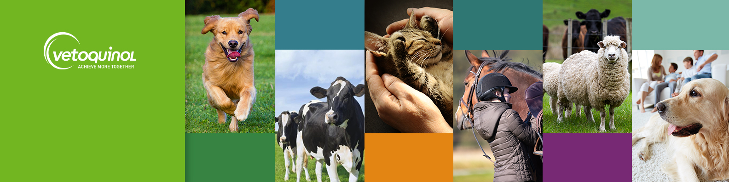

Join Our Team: Inside Sales Executive
We are seeking an enthusiastic Inside Sales Executive to join our team at our scenic Northamptonshire office.

The Opportunity:
- A role within a top 10 Global Animal Health player, in a market delivering consistent year-on-year growth.
- Work as part of our ambitious and high performing sales team.
- Enjoy hybrid working that ensures the perfect work-life balance.
- Work in a stunning rural business park, complete with gym facilities, walking and running trails and on-site café.
- Bring your furry friend to our dog-friendly office!

The Role:
- Cultivate strong relationships with vet practices through promotion and selling our products.
- Work closely with the field sales team to share information and knowledge to maintain competitive advantage and undertake collaborative field visits.
- Optimise market sales tools to target new business and manage current business opportunities.
- Develop optimised call plans in accordance with sales strategy to achieve and exceed targets.
- Be creative in producing and delivering virtual learning and online presentations to customers and prospective customers.
- Maintain current product knowledge of our and competitor products through regular product training.

We Value:
- Excellent communication skills and the ability to build rapport quickly.
- Proven experience in achieving sales targets.
- Being daring and results driven.
- Strong organisational and administrative skills.
- Effective teamwork and collaboration.
- Good negotiation skills.
- Experience of working in a telesales / customer service position.

Ready to join our passionate and driven team? Apply now and step into a role where your skills really matter. Email: uk_humanresources@vetoquinol.com to join a supportive environment with opportunities to grow.

