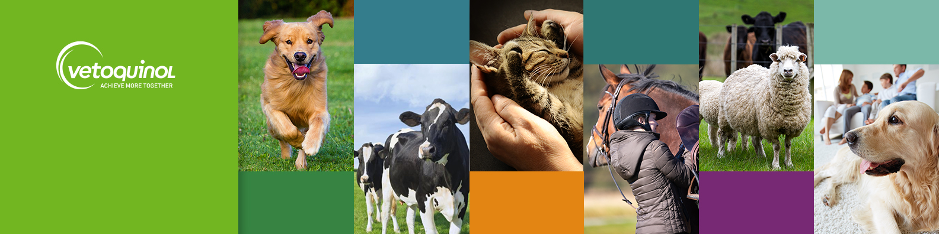

Join Our Team: Product Solutions & Technical Manager (Farm Animal)
We are seeking an enthusiastic Product Solutions & Technical Manager to join our team at our scenic Northamptonshire office.

The Opportunity:
- A role within a top 10 Global Animal Health player, in a market delivering consistent year-on-year growth.
- Work as part of our ambitious and high performing Solutions, Marketing, Key Accounts and Farm team.
- Enjoy hybrid working that ensures the perfect work-life balance.
- Work in a stunning rural business park, complete with gym facilities, walking and running trails and on-site café.
- Bring your furry friend to our dog-friendly office!

The Role:
- Propose and implements effective marketing plans for the Farm portfolio and related marketing campaigns
- Work closely with relevant departments to ensure the development and implementation of key marketing initiatives
- Partnering with key customers (incl Key Accounts) to understand and identify needs and develop relevant solutions
- Support the Farm business by providing technical services, support & insight
- Implements performance analysis and reporting tools to measure the effectiveness of marketing plans
- Work closely with Key Accounts and Farm business/sales teams to educate & train the solutions mindset and ensure understanding and implementation of developed solutions
- Develop relationships with key opinion leaders, press, key accounts, agencies, and professional organisations
We Value:
- MRCVS qualification
- Strong knowledge of Farm Animal veterinary industry along with excellent technical knowledge
- Deep understanding of Marketing principles / marketing qualifications (i.e CIM)
- Being daring and solutions driven
- Strong organisational and administrative skills.
- Effective teamwork and collaboration.

Ready to join our passionate and driven team? Apply now and step into a role where your skills really matter. Email: uk_humanresources@vetoquinol.com to join a supportive environment with opportunities to grow.

