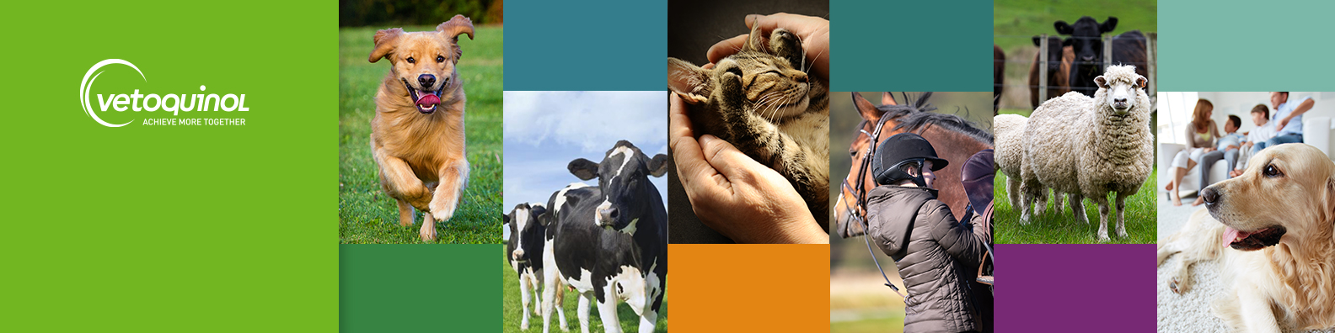

Join Our Team: Senior Product Manager – Companion Animal VET
We’re looking for a strategic and creative Senior Product Manager to join our passionate team at our Northamptonshire office. This is a full-time, permanent role offering the chance to make a real impact in the animal health industry.

The Opportunity:
- Be part of a top 10 global animal health company, operating in a thriving and resilient market.
- Join a collaborative and innovative Product Management team committed to excellence.
- Benefit from hybrid working arrangements that support work-life balance.
- Enjoy our scenic rural business park with gym access, walking trails and on-site café.
- Work in a dog-friendly office where your four-legged friend is welcome!

The Role:
- Lead the development of strategic and innovative marketing plans for the assigned portfolio, including our market-leading parasitology brand and implement tactical activation plans to optimise sales performance and brand awareness.
- Collaborate with global and local teams to translate marketing strategy into impactful execution.
- Use performance data and market intelligence to drive continuous improvement and identify emerging trends.
- Build and maintain strong relationships with key accounts, agencies and industry stakeholders to ensure organic growth and future stability.
- Manage sales and production forecasts, ensuring alignment with commercial goals.
- Represent Vetoquinol at industry events and congresses, elevating our brand presence.
- Support the creation of customer-centric business solutions in partnership with internal teams.

We Value:
- Established Product or Brand Manager with a strong marketing background and experience in the companion animal veterinary industry.
- Excellent communication and interpersonal skills with the ability to build rapport quickly.
- Strong organisational skills and attention to detail.
- A proactive, solution-focused mindset and a passion for innovation.
- A collaborative approach and commitment to team success.
- Financial acumen and experience managing budgets and forecasts.
- Alignment with our core values: Trust, Dare, Collaborate.

Ready to join us?
If you're ready to take the next step in your career and contribute to a company that values your expertise, we’d love to hear from you.
Apply now by emailing uk_humanresources@vetoquinol.com.

